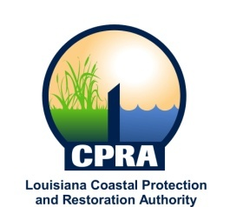

2017 Public Meetings

Johnny Bradberry, Chairman of the Coastal Protection and Restoration Authority, and Executive Assistant to Governor John Bel Edwards for Coastal Activities has announced the public meetings schedule for the Coastal Protection and Restoration Authority and the Governor’s Advisory Commission on Coastal Protection, Restoration and Conservation. Details on each meeting will be sent out at a later date. The dates and locations of these meetings are subject to change

CPRA
January 18, 2017
Baton Rouge, LA

February 15, 2017
Baton Rouge, LA

March 15, 2017
New Orleans, LA

April 19, 2017
Baton Rouge, LA

May 17, 2017
Baton Rouge, LA

June 21, 2017
Baton Rouge, LA

July 19, 2017
Chalmette, LA

August 16, 2017
Morgan City, LA

September 20, 2017
Baton Rouge, LA

October 18, 2017
Belle Chase, LA

November 15, 2017
Baton Rouge, LA

December 13, 2017
Baton Rouge, LA

Governor’s Advisory Commission
February 1, 2017
Baton Rouge, LA

March 29, 2017
New Orleans, LA

April 26, 2017
Baton Rouge, LA

July 12, 2017
Thibodaux, LA

November 2, 2017
New Orleans, LA

